ST. JOHN'S COLLEGE PALAYAMKOTTAI

TIRUNELVELI – 627002

NAAN MUDHALVAN SCHEME REPORT ON

**Unearthing the Environmental Impact of Human Activity: A Global CO2 Emission Analysis**

**TEAM MEMBERS**

**JOEL INFANT RAJ.S**

**ARUMUGA ENBARAJ**

**ANANDH .B**

**MOHAMED ANIBA .A**

ENBARAJ

[Email address]

**INTRODUCATION**

**OVERVIEW**

An overview of global CO2 emission data analysis, which offers insights into the amount and sources of CO2 emissions across different countries and regions. The report aims to present a comprehensive analysis of CO2 emissions data, including trends over time and the major contributors to global emissions. By understanding the impact of human activities on the environment, the report seeks to identify effective strategies to mitigate emissions and reduce the negative effects of climate change.

Global CO2 emission data analysis involves the study of CO2 emissions across the world and is an essential tool for understanding the impact of human activities on the environment. It provides valuable insights into the amount and sources of CO2 emissions, trends over time, and the major contributors to global emissions. Through data analysis, we can identify effective strategies to mitigate emissions and reduce the negative effects of climate change. Global CO2 emission data analysis is crucial for policymakers, scientists, and environmentalists to make informed decisions and take necessary actions to reduce emissions and combat climate change.

Global CO2 emissions refer to the amount of carbon dioxide released into the atmosphere by human activities, such as burning fossil fuels, deforestation, and industrial processes. The continued increase in CO2 emissions has resulted in global warming and climate change, leading to adverse effects on the environment and human life. Therefore, it is crucial to understand the sources and trends of global CO2 emissions through data analysis. Global CO2 emission data analysis helps identify the countries and industries responsible for the majority of emissions, allowing policymakers and organizations to develop and implement effective strategies to reduce emissions and combat climate change.

**PURPOSE**

The purpose of global CO2 emission analysis is to provide a comprehensive overview of the sources, trends, and patterns of CO2 emissions at a global level. This analysis helps us understand the scale of the problem of climate change caused by CO2 emissions, and to identify the regions and sectors that are most responsible for these emissions. It also provides insights into the effectiveness of policies and actions aimed at reducing CO2 emissions and mitigating climate change.

Specifically, global CO2 emission analysis serves the following purposes:

1. To inform policy decisions: Policymakers can use global CO2 emission analysis to inform the development and implementation of policies aimed at reducing CO2 emissions. By understanding the sources and trends of CO2 emissions, policymakers can identify the most effective strategies and interventions to reduce emissions.
2. To assess progress: Global CO2 emission analysis provides a basis for assessing progress in reducing emissions and achieving climate targets. By tracking emissions over time, we can evaluate the effectiveness of policies and actions, and adjust them as necessary.
3. To raise public awareness: Global CO2 emission analysis can help raise public awareness of the issue of climate change and the urgent need to reduce CO2 emissions. By providing clear and accessible information about the sources and impacts of CO2 emissions, we can engage a wider audience in the effort to reduce emissions.

Overall, global CO2 emission analysis plays a critical role in informing decision-making and action to address the global challenge of climate change caused by CO2 emissions.

**PROBLEM DEFINITION AND DESIGN THINKING**

EMPATHY MAP

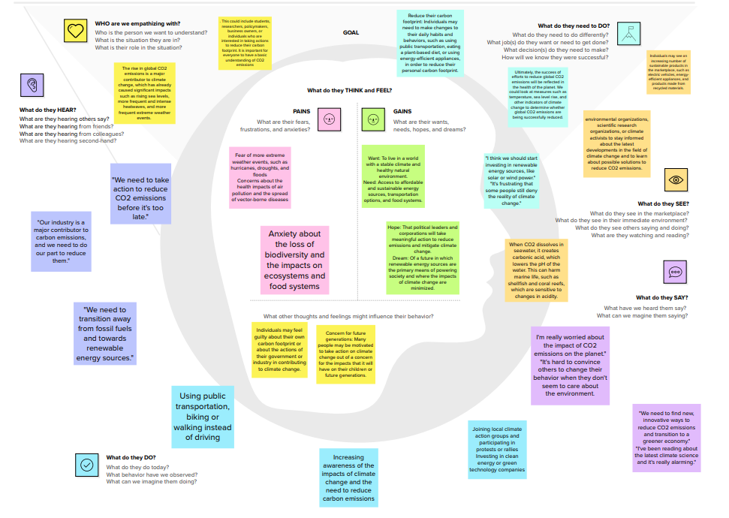

IDEATION AND BRAINSTORMING MAP

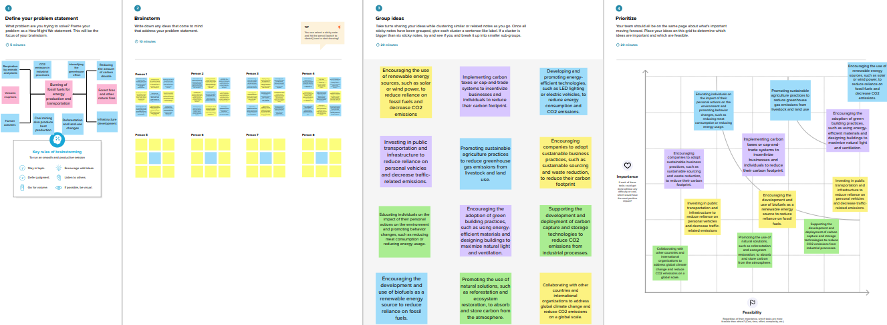

**RESULT :**

**DASH BOARD:-**

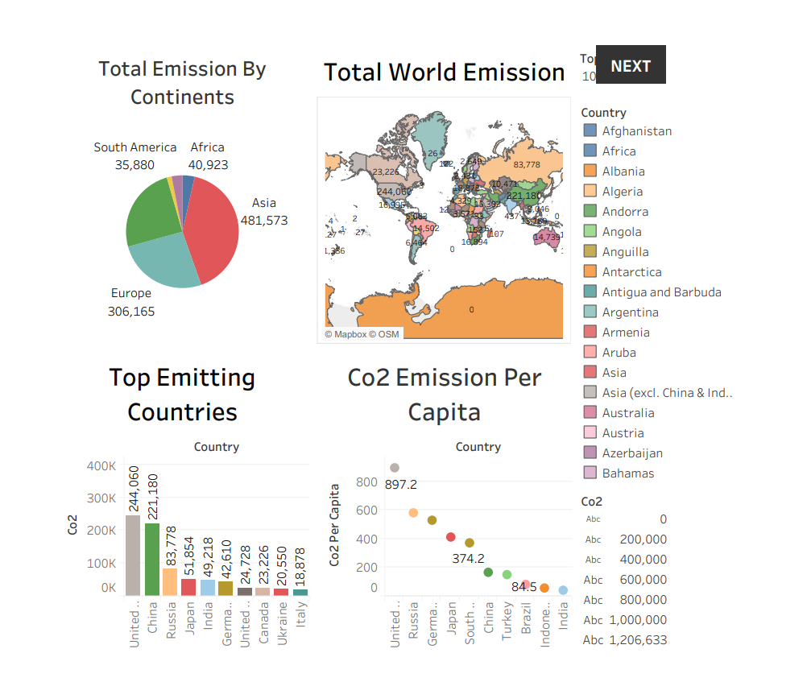

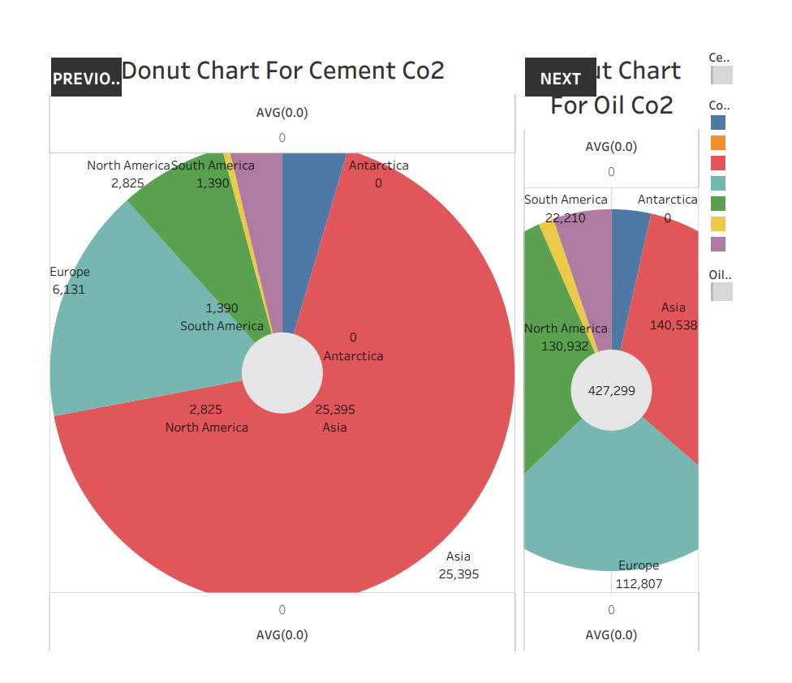

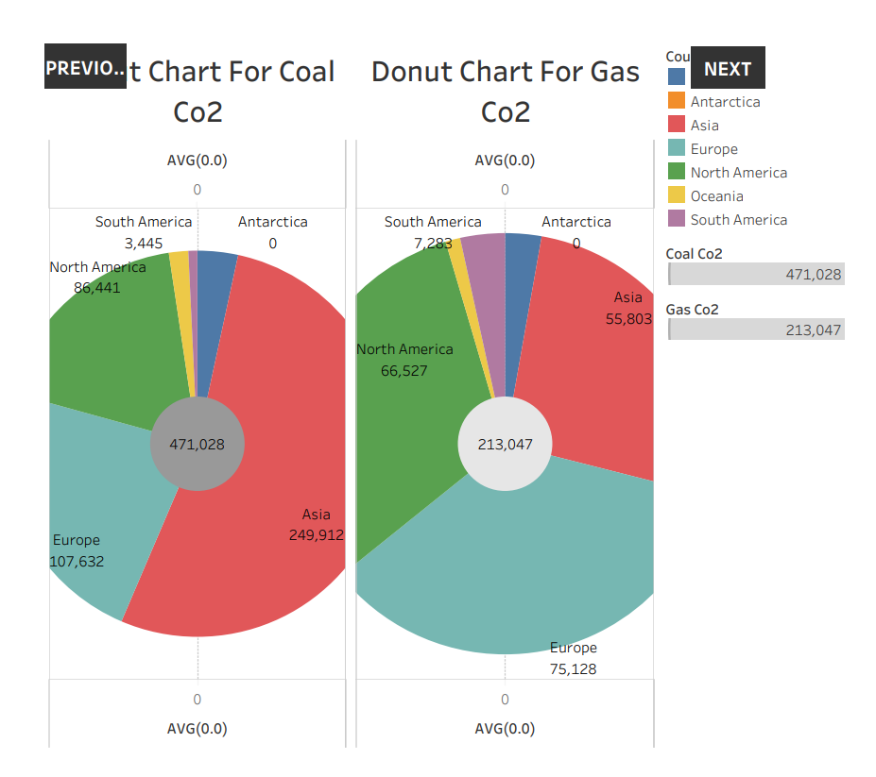

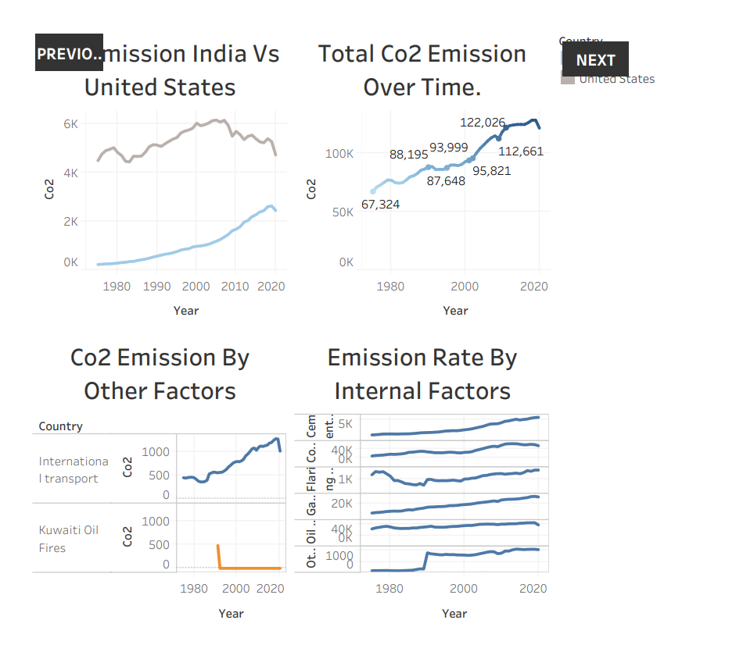

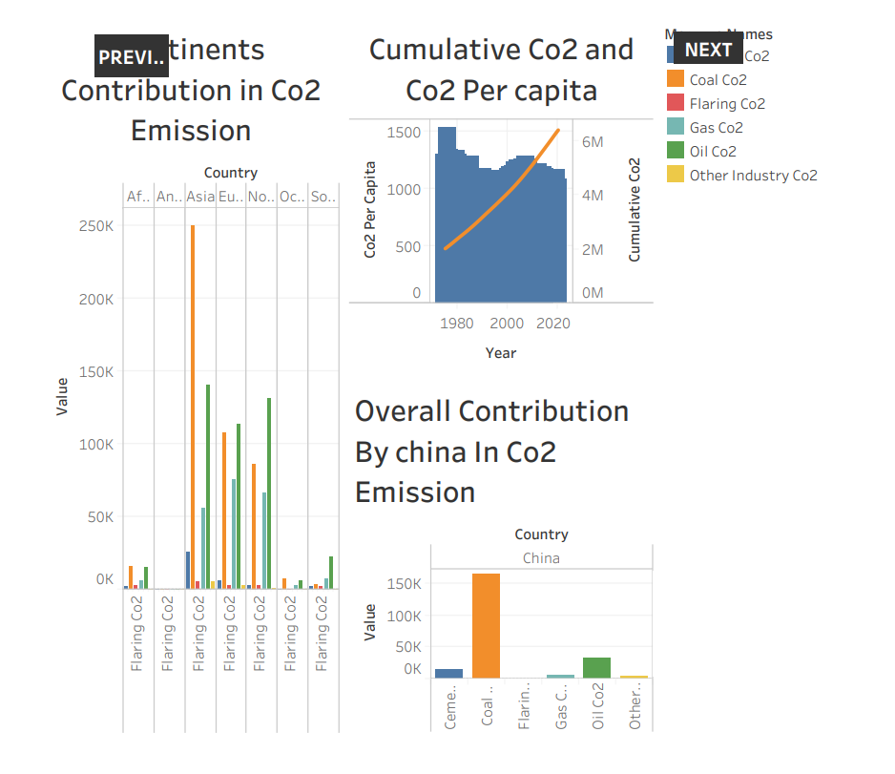

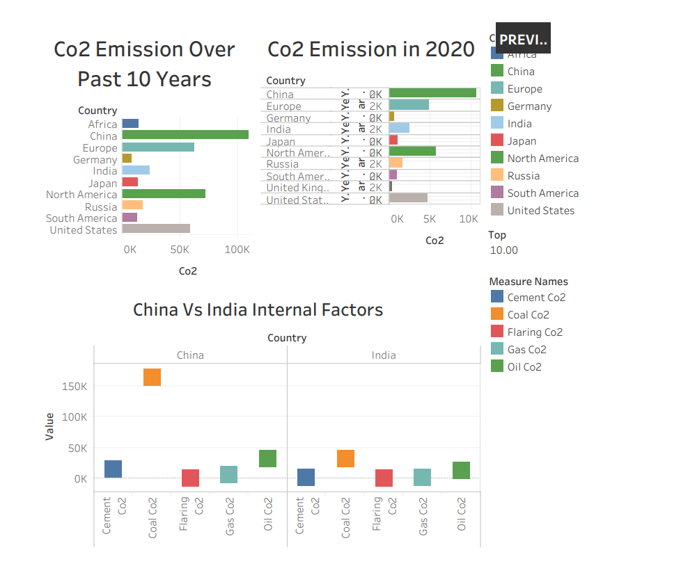

**STORY**

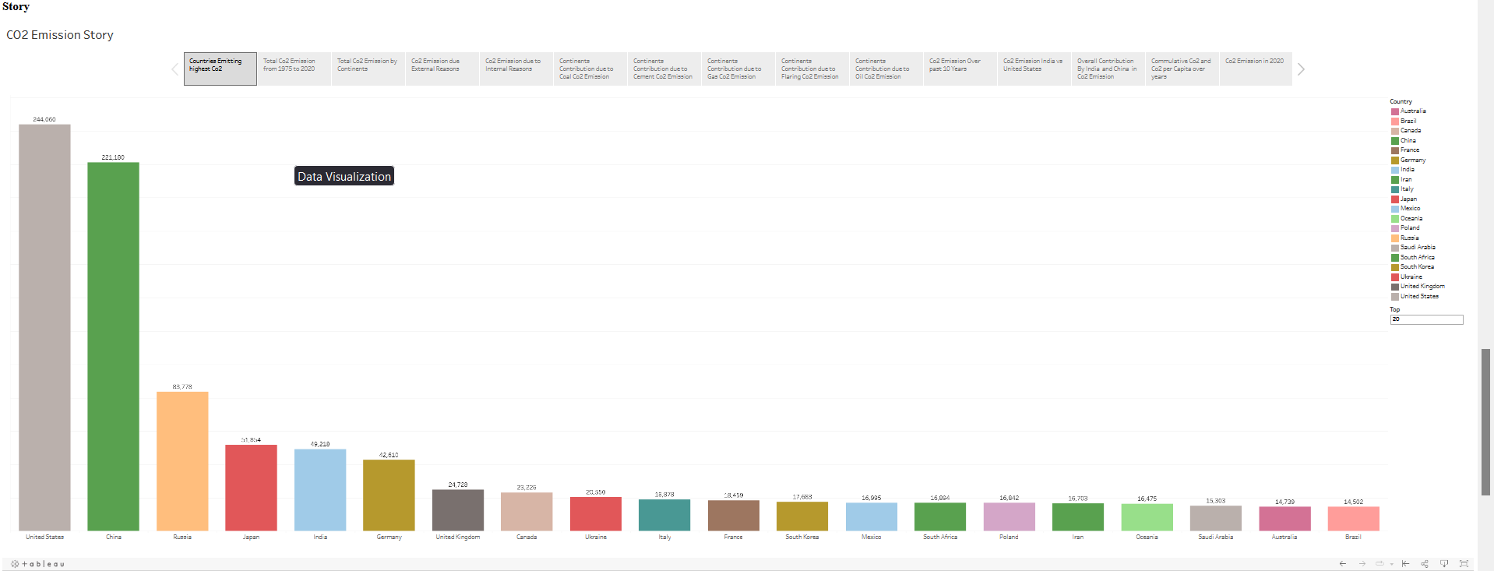

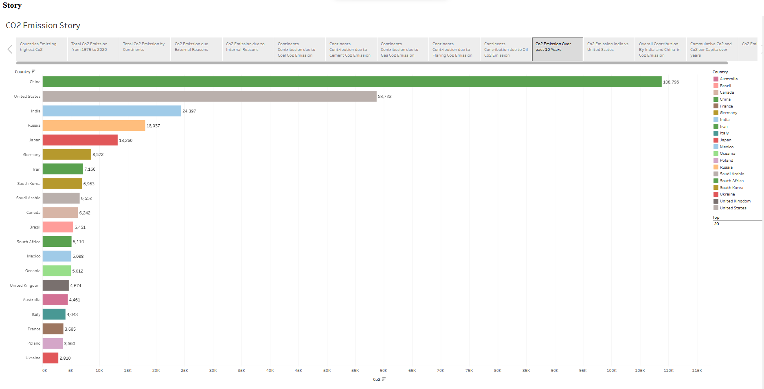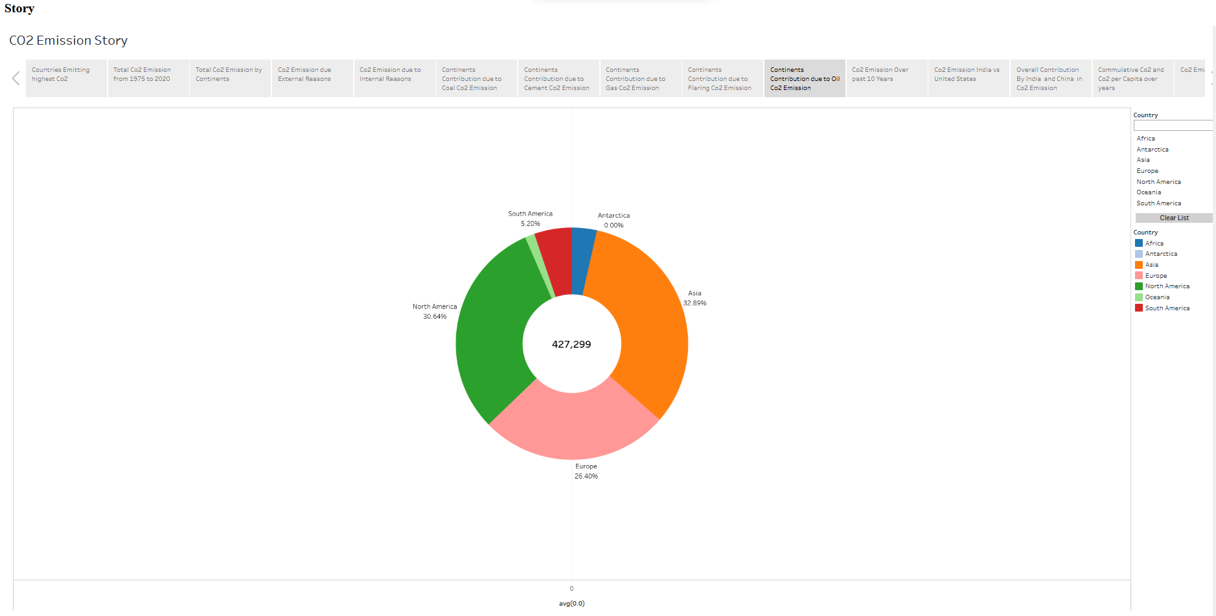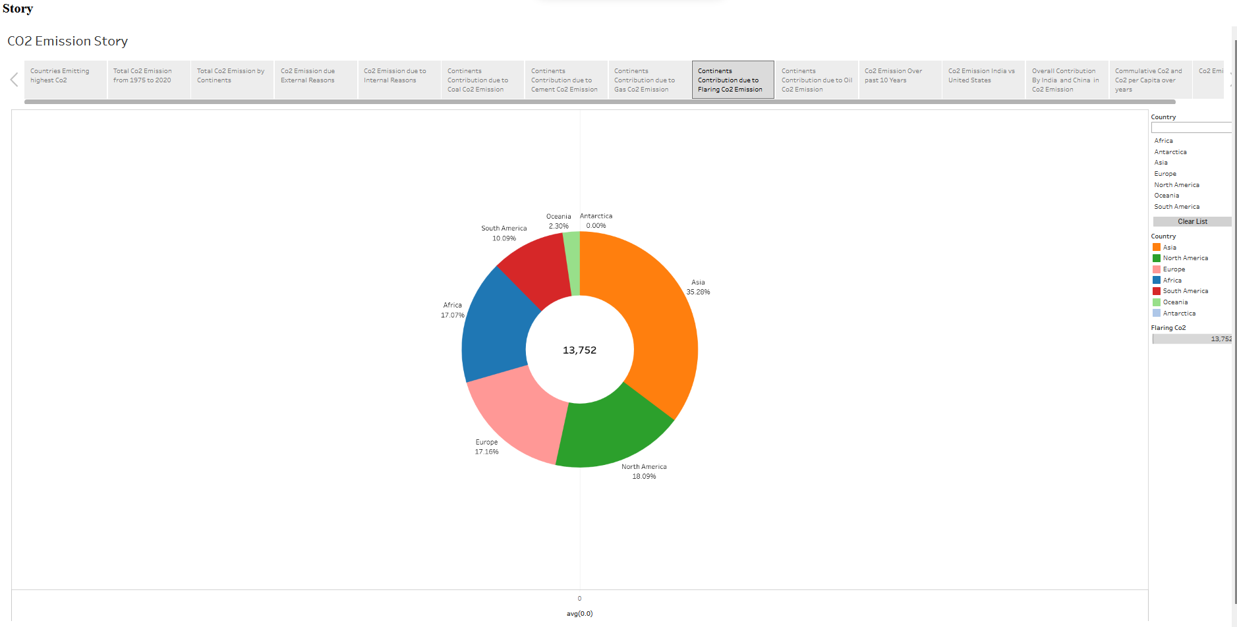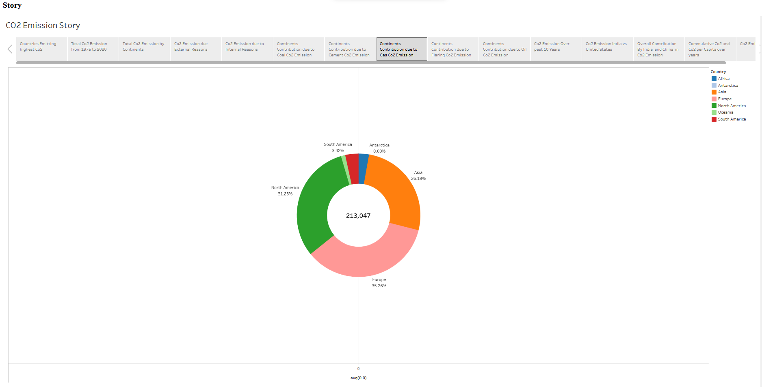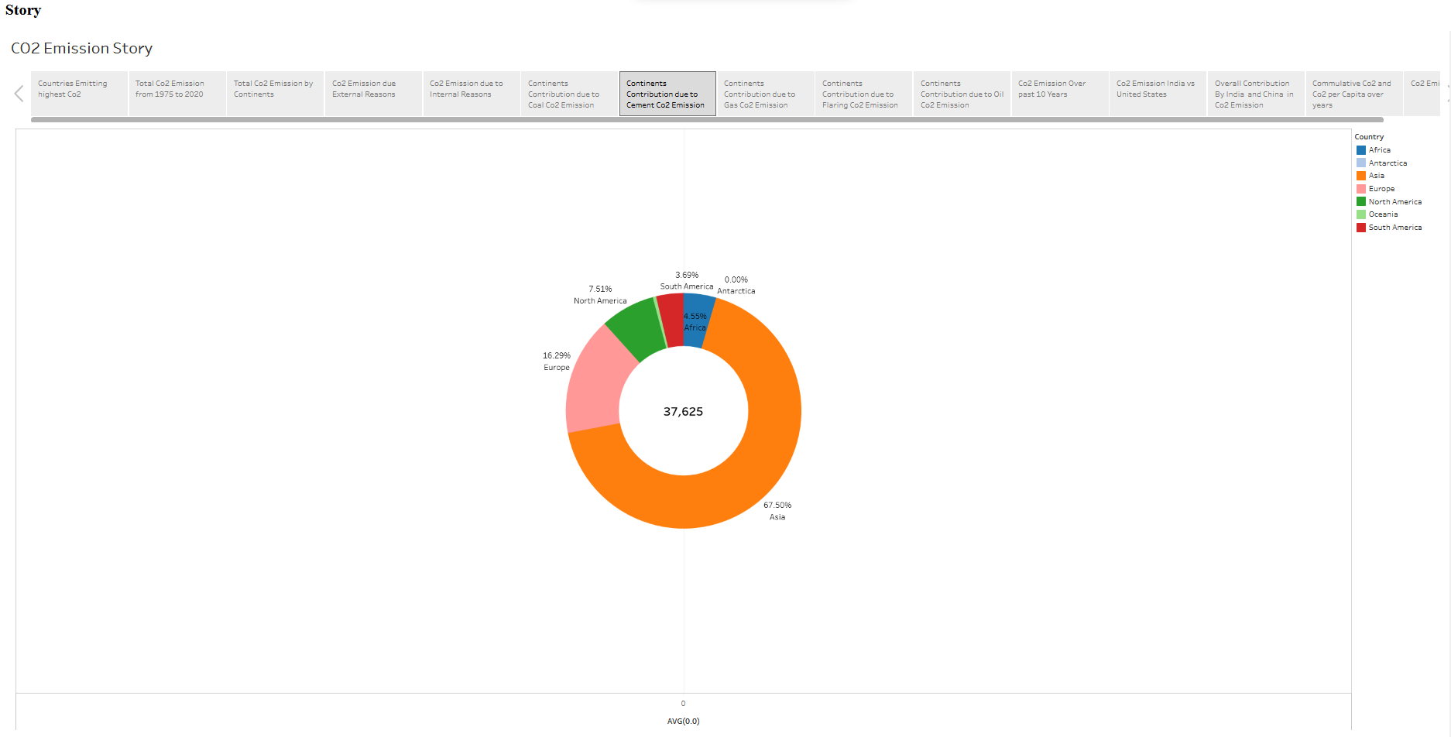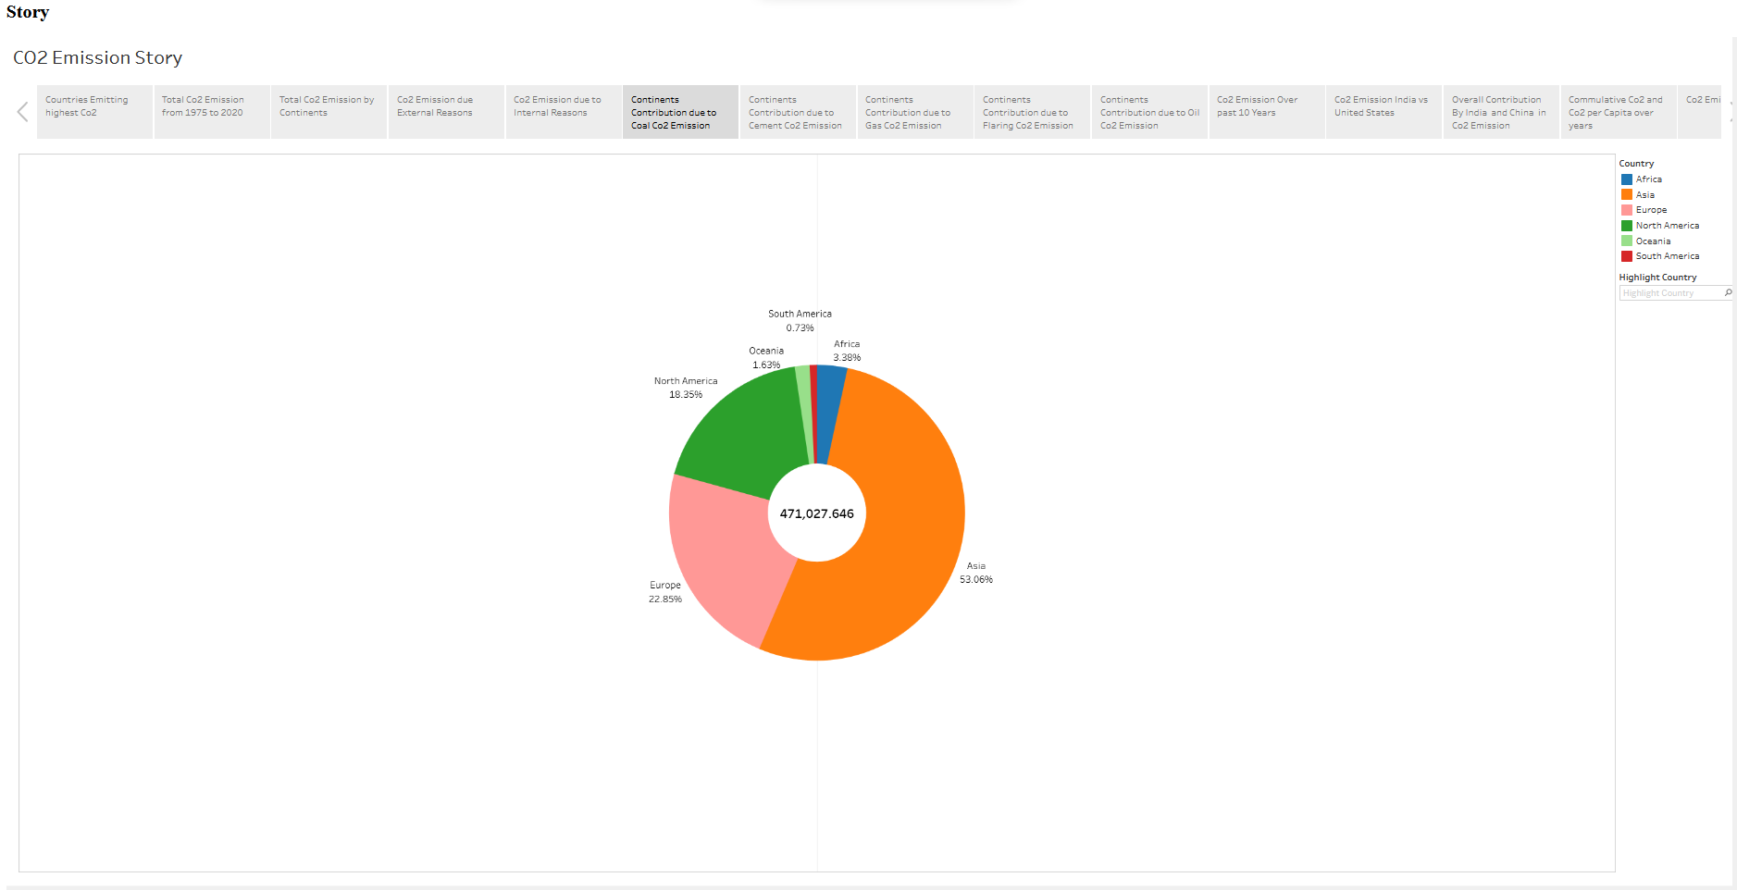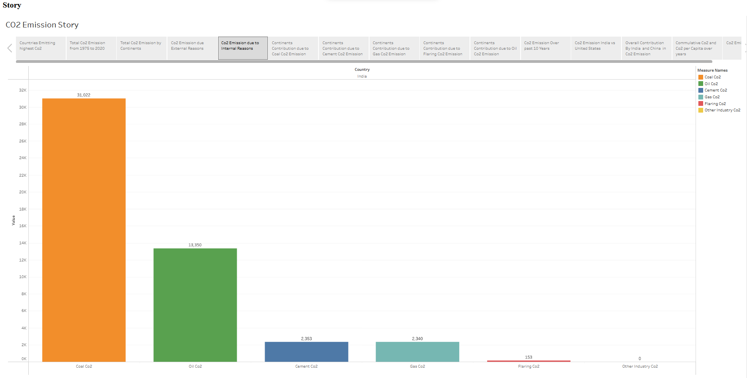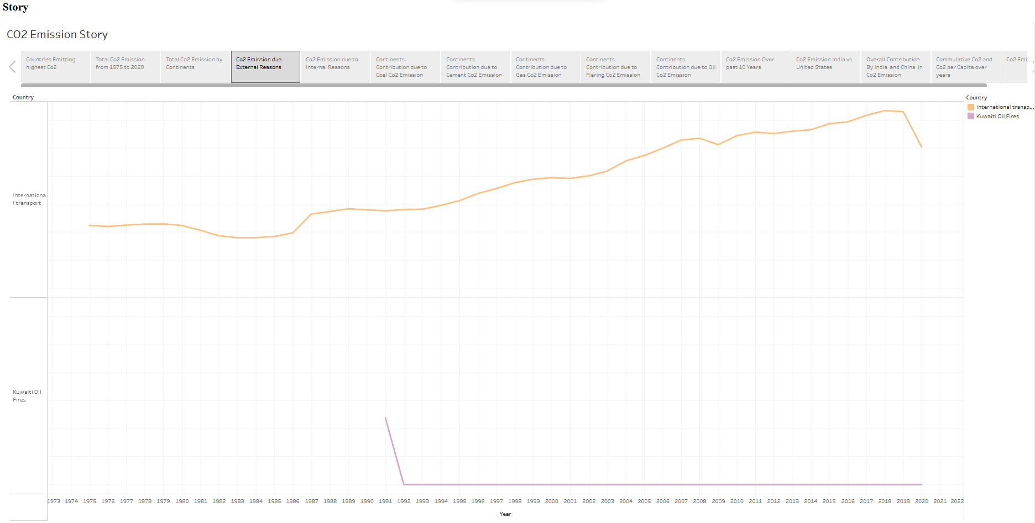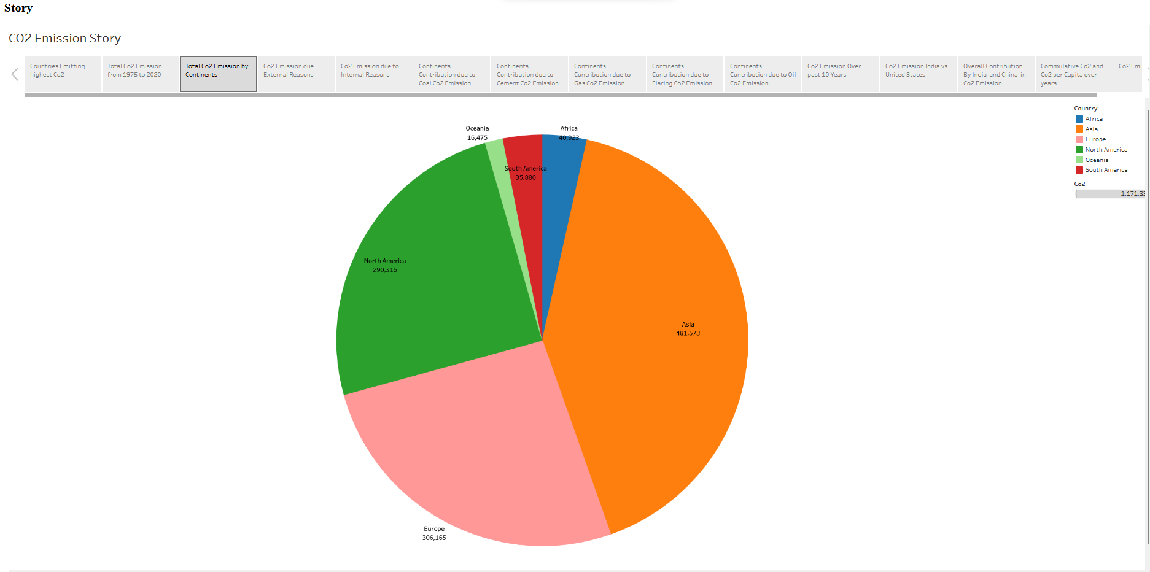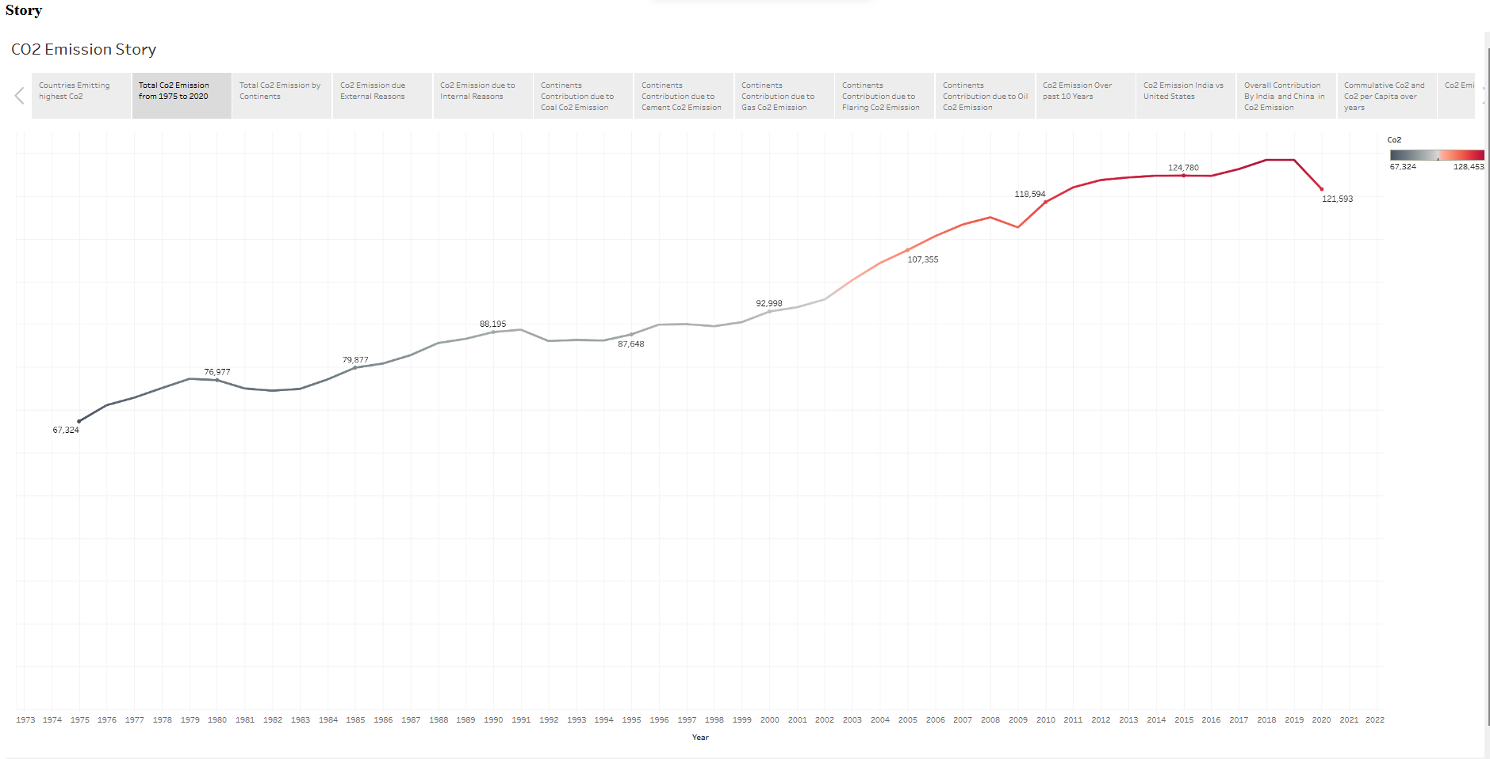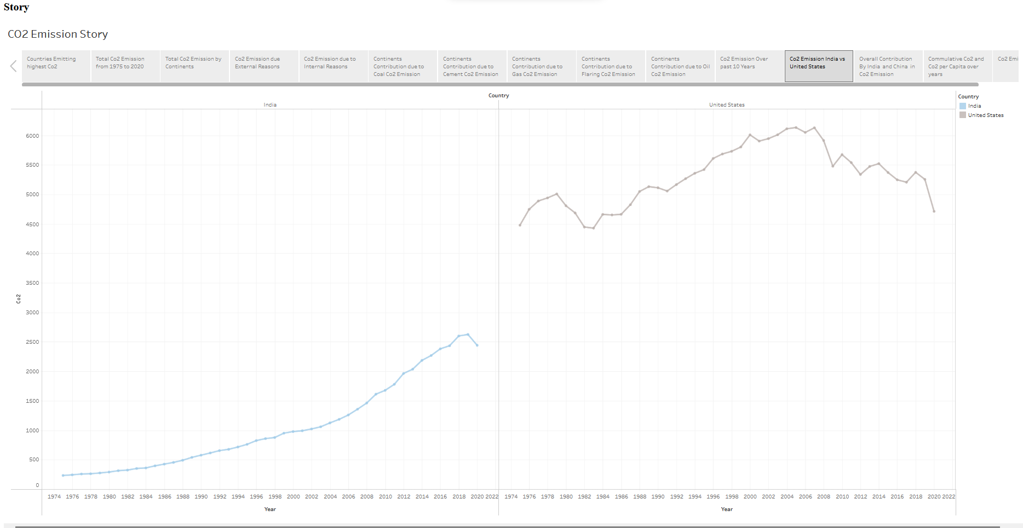

**WEB APPLICATION**

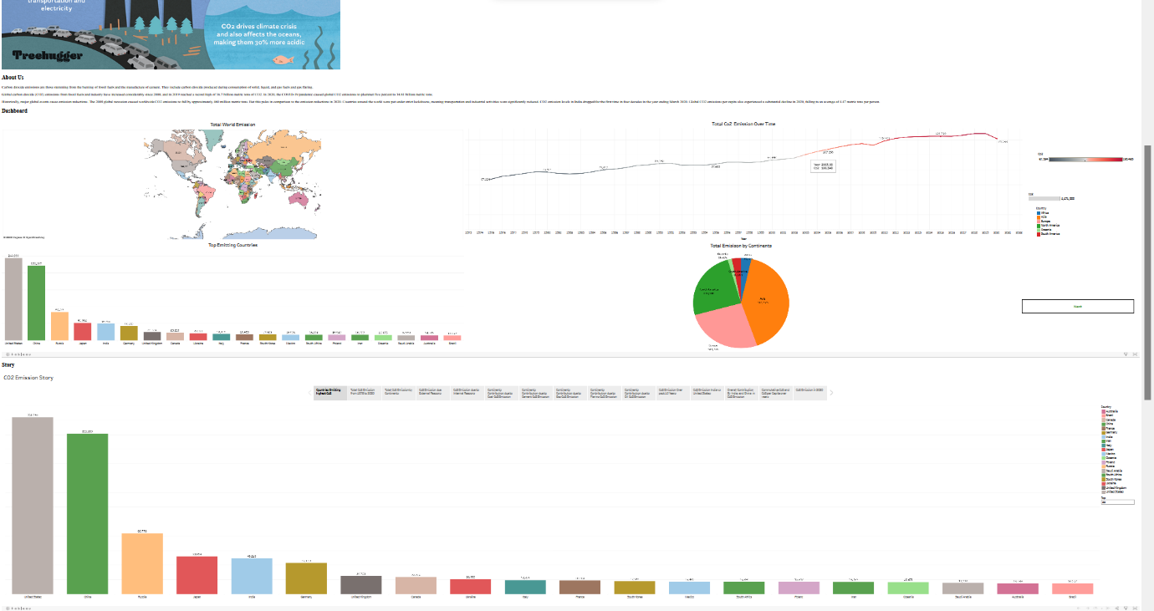

**ADVANTAGE AND DISADVANTAGE :-**

ADVANTAGES:

Advantages of global CO2 emission Analysis:

1. Identification of major contributors: Global CO2 emission analyses help identify the countries and industries responsible for the majority of emissions, allowing policymakers and organizations to target their efforts and resources towards the most significant contributors.
2. Understanding trends: Analyses of CO2 emission data over time help in understanding the trends in emissions and how they are changing, which is critical in developing effective mitigation strategies.
3. Comparison across countries and industries: Global CO2 emission analyses enable the comparison of emissions across countries and industries, providing insights into how different regions and sectors contribute to global emissions.
4. Evidence-based decision making: By providing accurate and reliable data, CO2 emission analyses support evidence-based decision making by policymakers, organizations, and individuals.
5. Monitoring progress: Global CO2 emission analyses allow for the monitoring of progress towards emissions reduction goals, helping to identify areas where additional efforts are required.

Overall, global CO2 emission analyses are essential in providing insights into the sources, trends, and impacts of CO2 emissions, enabling stakeholders to develop effective strategies to reduce emissions and combat climate change.

DISADVANTAGES:-

Disadvantages of global CO2 emission analysis:

1. Data quality: CO2 emission data is often incomplete, inaccurate, or outdated, which can result in significant errors and biases in analyses.
2. Limited coverage: While global CO2 emission analyses provide valuable insights into emissions on a global scale, they may not cover all countries or industries, which can limit their usefulness in developing targeted strategies.
3. Lack of standardization: CO2 emission data is often collected and reported using different methods and standards, making it difficult to compare data across countries and industries.
4. Incomplete picture of emissions: CO2 emission analyses often focus on direct emissions from energy use and industrial processes, while indirect emissions from areas such as agriculture and land use change are often overlooked.
5. Limited insight into causes: While global CO2 emission analyses can identify countries and industries responsible for emissions, they may not provide insight into the underlying causes of those emissions, which can limit the development of effective mitigation strategies.

Overall, while global CO2 emission analyses provide valuable insights into the sources, trends, and impacts of CO2 emissions, they are not without limitations and must be used in conjunction with other data and approaches to develop effective emissions reduction strategies.

**APPLICATIONS:**

The application of global CO2 emission analyses can be seen in a variety of areas, including:

1. Climate change policy: Global CO2 emission analyses are used to inform climate change policy decisions at national and international levels. The data is used to set emission reduction targets, establish carbon pricing policies, and design strategies to transition to a low-carbon economy.
2. Business and industry: Businesses and industries can use global CO2 emission analyses to identify areas of their operations that contribute to emissions and develop strategies to reduce their carbon footprint. The data can also inform investment decisions in low-carbon technologies and energy efficiency measures.
3. Academic research: Global CO2 emission analyses are used in academic research to understand the drivers of emissions, the impact of policy measures, and the potential for technological innovation to reduce emissions.
4. Public awareness: Global CO2 emission analyses can increase public awareness about the scale and urgency of the climate change challenge. The data can be used in public education campaigns to encourage individual actions to reduce emissions and support political action to address the issue.
5. International cooperation: Global CO2 emission analyses are used to facilitate international cooperation on climate change. The data is used in negotiations to establish global emission reduction targets and inform policies to support the transition to a low-carbon economy.

In summary, global CO2 emission analyses have important applications in informing policy decisions, business strategy, academic research, public awareness, and international cooperation to address the urgent challenge of climate change.

**CONCLUSION**

In conclusion, global CO2 emission analyses are essential tools for understanding the scale and urgency of the climate change challenge. These analyses provide a comprehensive view of the amount of carbon dioxide emitted by different countries and sectors, which can help identify the biggest emitters and where efforts to reduce emissions should be focused.

By using this information, governments, businesses, and individuals can develop effective strategies to reduce emissions and transition to a low-carbon economy. The data can also inform international negotiations and cooperation on climate change, which is crucial for addressing this global challenge.

However, there are limitations and challenges associated with global CO2 emission analyses, including incomplete data, biases, and politics. It is essential to address these limitations and work towards more accurate and comprehensive analyses to inform effective policy decisions.

In summary, global CO2 emission analyses are an essential tool for addressing the urgent challenge of climate change. By using this data to inform policy decisions, businesses and individuals can take action to reduce emissions and mitigate the impact of climate change on our planet..

**FUTURE SCOPE**

Controlling global CO2 emissions will require a range of actions and strategies, implemented on a global scale. Some potential approaches to reducing emissions and mitigating the impacts of climate change include:

1. Implementing policies and regulations: Governments can play a critical role in reducing CO2 emissions by implementing policies and regulations that incentivize the adoption of low-carbon technologies and practices. For example, governments can impose taxes or cap-and-trade systems on carbon emissions, and offer subsidies or tax incentives for renewable energy and energy-efficient technologies.
2. Investing in renewable energy: The transition to renewable energy sources such as wind, solar, and hydropower can significantly reduce CO2 emissions from electricity generation. Governments, businesses, and individuals can invest in renewable energy infrastructure and support the development of new technologies to improve the efficiency and affordability of renewable energy.
3. Improving energy efficiency: Improving the efficiency of buildings, transportation, and industrial processes can also reduce CO2 emissions. This can be achieved through the adoption of energy-efficient technologies, such as LED lighting and electric vehicles, and through building design and retrofits that reduce energy use.
4. Promoting sustainable land use practices: Land use change, such as deforestation and urbanization, is a significant contributor to global CO2 emissions. Promoting sustainable land use practices, such as reforestation and urban green spaces, can help to mitigate these emissions.
5. Raising awareness and changing behavior: Changing consumer behavior and raising awareness about the impacts of climate change can also help to reduce CO2 emissions. This can be achieved through education campaigns, carbon labeling, and incentivizing sustainable consumer choices.

Overall, controlling global CO2 emissions will require a concerted effort by governments, businesses, and individuals around the world. It will require a combination of policy changes, technological innovations, and changes in behavior to transition to a low-carbon economy and mitigate the impacts of climate change.

**APPENDIX**

<!DOCTYPE html>

<html lang="en">

<head>

<meta charset="utf-8">

<meta content="width=device-width, initial-scale=1.0" name="viewport">

<title>Global Co2 Emission Analysis</title>

<meta content="" name="description">

<meta content="" name="keywords">

<!-- Favicons -->

<link href="assets/img/favicon.png" rel="icon">

<link href="assets/img/apple-touch-icon.png" rel="apple-touch-icon">

<!-- Google Fonts -->

<link href="https://fonts.googleapis.com/css?family=Open+Sans:300,300i,400,400i,600,600i,700,700i|Jost:300,300i,400,400i,500,500i,600,600i,700,700i|Poppins:300,300i,400,400i,500,500i,600,600i,700,700i" rel="stylesheet">

<!-- Vendor CSS Files -->

<link href="assets/vendor/aos/aos.css" rel="stylesheet">

<link href="assets/vendor/bootstrap/css/bootstrap.min.css" rel="stylesheet">

<link href="assets/vendor/bootstrap-icons/bootstrap-icons.css" rel="stylesheet">

<link href="assets/vendor/boxicons/css/boxicons.min.css" rel="stylesheet">

<link href="assets/vendor/glightbox/css/glightbox.min.css" rel="stylesheet">

<link href="assets/vendor/remixicon/remixicon.css" rel="stylesheet">

<link href="assets/vendor/swiper/swiper-bundle.min.css" rel="stylesheet">

<!-- Template Main CSS File -->

<link href="assets/css/style.css" rel="stylesheet">

<!-- =======================================================

* Template Name: Arsha - v4.10.0

* Template URL: https://bootstrapmade.com/arsha-free-bootstrap-html-template-corporate/

* Author: BootstrapMade.com

* License: https://bootstrapmade.com/license/

======================================================== -->

</head>

<body>

<!-- ======= Header ======= -->

<header id="header" class="fixed-top ">

<div class="container d-flex align-items-center justify-content-between">

<h1 class="logo"><img src="https://media.istockphoto.com/id/1323550608/vector/co2-reduction-cloud-eco-vector-icon.jpg?s=612x612&w=0&k=20&c=jO3OZfYAg9gB8TWvzH8BR64Lq3pFrfHcOvxpSgB-cjA="> </h1>

<!-- Uncomment below if you prefer to use an image logo -->

<!-- <a href="index.html" class="logo me-auto"><img src="assets/img/logo.png" alt="" class="img-fluid"></a>-->

<nav id="navbar" class="navbar">

<ul>

<li><a class="nav-link scrollto active" href="#hero">Home</a></li>

<li><a class="nav-link scrollto" href="#about">About</a></li>

<li><a class="nav-link scrollto" href="#dash">Dashboard</a></li>

<li><a class="nav-link scrollto" href="#services">Story</a></li>

`

<li><a class="nav-link scrollto" href="#report">Report</a></li>

<li><a class="nav-link scrollto" href="#contact">Contact</a></li>

</ul>

<i class="bi bi-list mobile-nav-toggle"></i>

</nav>

<!-- .navbar -->

</div>

</header>

<!-- End Header -->

<!-- ======= Hero Section ======= -->

<section id="hero" class="d-flex align-items-center">

<div class="container">

<div class="row">

<div class="col-lg-6 d-flex flex-column justify-content-center pt-4 pt-lg-0 order-2 order-lg-1" data-aos="fade-up" data-aos-delay="200">

<h1>Welcome to Global Co2 Emission Analysis for Year 2020</h1>

<h2>Carbon dioxide emissions are the primary driver of global climate change. It’s widely recognised that to avoid the worst impacts of climate change, the world needs to urgently reduce emissions.</h2>

<div class="d-flex justify-content-center justify-content-lg-start">

<a href="#about" class="btn-get-started scrollto">Get Started</a>

<a href="https://www.youtube.com/watch?v=jDDaplaOz7Q" class="glightbox btn-watch-video"></a>

</div>

</div>

<div class="col-lg-6 order-1 order-lg-2 hero-img" data-aos="zoom-in" data-aos-delay="200">

<img src="https://www.treehugger.com/thmb/LbdMV9gbfA1S7Y3SB0XhlSl4EFw=/1500x0/filters:no_upscale():max_bytes(150000):strip_icc()/co-why-is-carbon-dioxide-bad-4864246_V2-4ea7c0936b5a4cd3b8d4f2b41ec02f63.png" class="img-fluid animated" alt="">

</div>

</div>

</div>

</section>

<!-- End Hero -->

<main id="main">

<!-- ======= Clients Section ======= -->

<!-- End Cliens Section -->

<!-- ======= About Us Section ======= -->

<section id="about" class="about">

<div class="container">

<div class="section-title">

<h2>About Us</h2>

</div>

<div class="row content">

<div class="col-lg-12">

<p>

Carbon dioxide emissions are those stemming from the burning of fossil fuels and the manufacture of cement. They include carbon dioxide produced during consumption of solid, liquid, and gas fuels and gas flaring.

</p>

<p>

Global carbon dioxide (CO2) emissions from fossil fuels and industry have increased considerably since 2000, and in 2019 reached a record high of 36.7 billion metric tons of CO2. In 2020, the COVID-19 pandemic caused global CO2 emissions to plummet five

percent to 34.81 billion metric tons.</p>

<p> Historically, major global events cause emission reductions. The 2009 global recession caused worldwide CO2 emissions to fall by approximately 460 million metric tons. But this pales in comparison to the emission reductions in

2020. Countries around the world were put under strict lockdowns, meaning transportation and industrial activities were significantly reduced. CO2 emission levels in India dropped for the first time in four decades in the year

ending March 2020. Global CO2 emissions per capita also experienced a substantial decline in 2020, falling to an average of 4.47 metric tons per person.</p>

</div>

</div>

</div>

</section>

<!-- End About Us Section -->

<!-- ======= Why Us Section ======= -->

<section id="dash" class="">

<div class="container-fluid" data-aos="fade-up">

<div class="section-title">

<h2>Dashboard</h2>

</div>

<div class='tableauPlaceholder' id='viz1681723705186' style='position: relative'><noscript><a href='#'><img alt=' ' src='https:&#47;&#47;public.tableau.com&#47;static&#47;images&#47;ta&#47;tableauvizulisation&#47;Dashboard1&#47;1_rss.png' style='border: none' /></a></noscript><object class='tableauViz' style='display:none;'><param name='host_url' value='https%3A%2F%2Fpublic.tableau.com%2F' /> <param name='embed_code_version' value='3' /> <param name='site_root' value='' /><param name='name' value='tableauvizulisation&#47;Dashboard1' /><param name='tabs' value='yes' /><param name='toolbar' value='yes' /><param name='static_image' value='https:&#47;&#47;public.tableau.com&#47;static&#47;images&#47;ta&#47;tableauvizulisation&#47;Dashboard1&#47;1.png' /> <param name='animate_transition' value='yes' /><param name='display_static_image' value='yes' /><param name='display_spinner' value='yes' /><param name='display_overlay' value='yes' /><param name='display_count' value='yes' /><param name='language' value='en-US' /><param name='filter' value='publish=yes' /></object></div> <script type='text/javascript'> var divElement = document.getElementById('viz1681723705186'); var vizElement = divElement.getElementsByTagName('object')[0]; if ( divElement.offsetWidth > 800 ) { vizElement.style.minWidth='1016px';vizElement.style.maxWidth='100%';vizElement.style.minHeight='1014px';vizElement.style.maxHeight=(divElement.offsetWidth*0.75)+'px';} else if ( divElement.offsetWidth > 500 ) { vizElement.style.minWidth='1016px';vizElement.style.maxWidth='100%';vizElement.style.minHeight='1014px';vizElement.style.maxHeight=(divElement.offsetWidth*0.75)+'px';} else { vizElement.style.minWidth='1016px';vizElement.style.maxWidth='100%';vizElement.style.minHeight='1500px';vizElement.style.maxHeight=(divElement.offsetWidth*1.77)+'px';} var scriptElement = document.createElement('script'); scriptElement.src = 'https://public.tableau.com/javascripts/api/viz_v1.js'; vizElement.parentNode.insertBefore(scriptElement, vizElement); </script>

<param name='tabs' value='no' /><param name='toolbar' value='yes' />

<param name='static_image' value='https:&#47;&#47;public.tableau.com&#47;static&#47;images&#47;Co&#47;Co2dash&#47;Dashboard1&#47;1.png' />

<param name='animate_transition' value='yes' />

<param name='display_static_image' value='yes' />

<param name='toolbar' value='no' />

<param name='display_spinner' value='yes' />

<param name='display_overlay' value='yes' />

<param name='display_count' value='yes' />

<param name='language' value='en-US' />

<param name='showShareOptions' value='false' />

</object>

</div>

<script type='text/javascript'>

var divElement = document.getElementById('viz1672205035633');

var vizElement = divElement.getElementsByTagName('object')[0];

if (divElement.offsetWidth > 800) {

vizElement.style.width = '100%';

vizElement.style.height = (divElement.offsetWidth * 0.75) + 'px';

} else if (divElement.offsetWidth > 500) {

vizElement.style.width = '90%';

vizElement.style.height = (divElement.offsetWidth * 0.75) + 'px';

} else {

vizElement.style.width = '100%';

vizElement.style.height = '1477px';

}

var scriptElement = document.createElement('script');

scriptElement.src = 'https://public.tableau.com/javascripts/api/viz_v1.js';

vizElement.parentNode.insertBefore(scriptElement, vizElement);

</script>

</div>

<!-- End Why Us Section -->

<section id="services" class="services">

<div class="container" data-aos="fade-up">

<div class="section-title">

<h2>Story</h2>

</div>

<div class='tableauPlaceholder' id='viz1681724037497' style='position: relative'><noscript><a href='#'><img alt=' ' src='https:&#47;&#47;public.tableau.com&#47;static&#47;images&#47;ta&#47;tableauvizulisation&#47;Story1&#47;1_rss.png' style='border: none' /></a></noscript><object class='tableauViz' style='display:none;'><param name='host_url' value='https%3A%2F%2Fpublic.tableau.com%2F' /> <param name='embed_code_version' value='3' /> <param name='site_root' value='' /><param name='name' value='tableauvizulisation&#47;Story1' /><param name='tabs' value='yes' /><param name='toolbar' value='yes' /><param name='static_image' value='https:&#47;&#47;public.tableau.com&#47;static&#47;images&#47;ta&#47;tableauvizulisation&#47;Story1&#47;1.png' /> <param name='animate_transition' value='yes' /><param name='display_static_image' value='yes' /><param name='display_spinner' value='yes' /><param name='display_overlay' value='yes' /><param name='display_count' value='yes' /><param name='language' value='en-US' /><param name='filter' value='publish=yes' /></object></div> <script type='text/javascript'> var divElement = document.getElementById('viz1681724037497'); var vizElement = divElement.getElementsByTagName('object')[0]; vizElement.style.width='1016px';vizElement.style.height='1014px'; var scriptElement = document.createElement('script'); scriptElement.src = 'https://public.tableau.com/javascripts/api/viz_v1.js'; vizElement.parentNode.insertBefore(scriptElement, vizElement); </script>

</noscript><object class='tableauViz' style='display:none;'>

<param name='host_url' value='https%3A%2F%2Fpublic.tableau.com%2F' />

<param name='embed_code_version' value='3' /> <param name='path' value='shared&#47;G4Q8N94F4' />

<param name='toolbar' value='yes' />

<param name='static_image' value='https:&#47;&#47;public.tableau.com&#47;static&#47;images&#47;G4&#47;G4Q8N94F4&#47;1.png' />

<param name='animate_transition' value='yes' />

<param name='display_static_image' value='yes' />

<param name='display_spinner' value='yes' />

<param name='display_overlay' value='yes' />

<param name='display_count' value='yes' />

<param name='language' value='en-US' /></object></div>

<script type='text/javascript'>

var divElement = document.getElementById('viz1672206123585');

var vizElement = divElement.getElementsByTagName('object')[0];

vizElement.style.width = '100%';

vizElement.style.height = (divElement.offsetWidth * 0.75) + 'px';

var scriptElement = document.createElement('script');

scriptElement.src = 'https://public.tableau.com/javascripts/api/viz_v1.js';

vizElement.parentNode.insertBefore(scriptElement, vizElement);

</script>

</div>

</section>

<!-- ======= Skills Section ======= -->

<!-- End Skills Section -->

<!-- End Services Section -->

<!-- ======= Cta Section ======= -->

<!-- End Cta Section -->

<!-- ======= Portfolio Section ======= -->

<section id="portfolio" class="portfolio">

<div class="container" data-aos="fade-up">

<!-- End Portfolio Section -->

<!-- ======= Team Section ======= -->

<!-- End Team Section -->

<!-- ======= Pricing Section ======= -->

<!-- End Pricing Section -->

<!-- ======= Contact Section ======= -->

<section id="contact" class="contact">

<div class="container" data-aos="fade-up">

<div class="section-title">

<h2>Contact</h2>

</div>

<div class="row">

<div class="col-lg-5 d-flex align-items-stretch">

<div class="info">

<div class="address">

<i class="bi bi-geo-alt"></i>

<h4>Location:</h4>

<p>SmartBridge, Hyderabad,AndhraPradesh, India</p>

</div>

<div class="email">

<i class="bi bi-envelope"></i>

<h4>Email:</h4>

<p>info@smartbridge.com<br>contact@smartbridge.com</p>

</div>

<div class="phone">

<i class="bi bi-phone"></i>

<h4>Call:</h4>

<p>+11 1234 1234<br>+11 4321 4321</p>

</div>

</div>

</div>

<div class="col-lg-7 mt-5 mt-lg-0 d-flex align-items-stretch">

<form action="forms/contact.php" method="post" role="form" class="php-email-form">

<div class="row">

<div class="form-group col-md-6">

<label for="name">Your Name</label>

<input type="text" name="name" class="form-control" id="name" required>

</div>

<div class="form-group col-md-6">

<label for="name">Your Email</label>

<input type="email" class="form-control" name="email" id="email" required>

</div>

</div>

<div class="form-group">

<label for="name">Subject</label>

<input type="text" class="form-control" name="subject" id="subject" required>

</div>

<div class="form-group">

<label for="name">Message</label>

<textarea class="form-control" name="message" rows="10" required></textarea>

</div>

<div class="my-3">

<div class="loading">Loading</div>

<div class="error-message"></div>

<div class="sent-message">Your message has been sent. Thank you!</div>

</div>

<div class="text-center"><button type="submit">Send Message</button></div>

</form>

</div>

</div>

</div>

</section>

<!-- End Contact Section -->

</main>

<!-- End #main -->

<!-- ======= Footer ======= -->

<footer id="footer">

<div class="footer-top">

<div class="container">

</div>

</div>

<div class="container footer-bottom clearfix">

<div class="copyright">

&copy; Copyright <strong><span>Arsha</span></strong>. All Rights Reserved

</div>

<div class="credits">

<!-- All the links in the footer should remain intact. -->

<!-- You can delete the links only if you purchased the pro version. -->

<!-- Licensing information: https://bootstrapmade.com/license/ -->

<!-- Purchase the pro version with working PHP/AJAX contact form: https://bootstrapmade.com/arsha-free-bootstrap-html-template-corporate/ -->

Designed by <a href="https://bootstrapmade.com/">Indra Prakash</a>

<div class="social-links mt-3">

<a href="#" class="twitter"><i class="bx bxl-twitter"></i></a>

<a href="#" class="facebook"><i class="bx bxl-facebook"></i></a>

<a href="#" class="instagram"><i class="bx bxl-instagram"></i></a>

<a href="#" class="google-plus"><i class="bx bxl-skype"></i></a>

<a href="#" class="linkedin"><i class="bx bxl-linkedin"></i></a>

</div>

</div>

</div>

</footer>

<!-- End Footer -->

<div id="preloader"></div>

<a href="#" class="back-to-top d-flex align-items-center justify-content-center"><i class="bi bi-arrow-up-short"></i></a>

<!-- Vendor JS Files -->

<script src="assets/vendor/aos/aos.js"></script>

<script src="assets/vendor/bootstrap/js/bootstrap.bundle.min.js"></script>

<script src="assets/vendor/glightbox/js/glightbox.min.js"></script>

<script src="assets/vendor/isotope-layout/isotope.pkgd.min.js"></script>

<script src="assets/vendor/swiper/swiper-bundle.min.js"></script>

<script src="assets/vendor/waypoints/noframework.waypoints.js"></script>

<script src="assets/vendor/php-email-form/validate.js"></script>

<!-- Template Main JS File -->

<script src="assets/js/main.js"></script>

</body>

</html>

Regenerate response